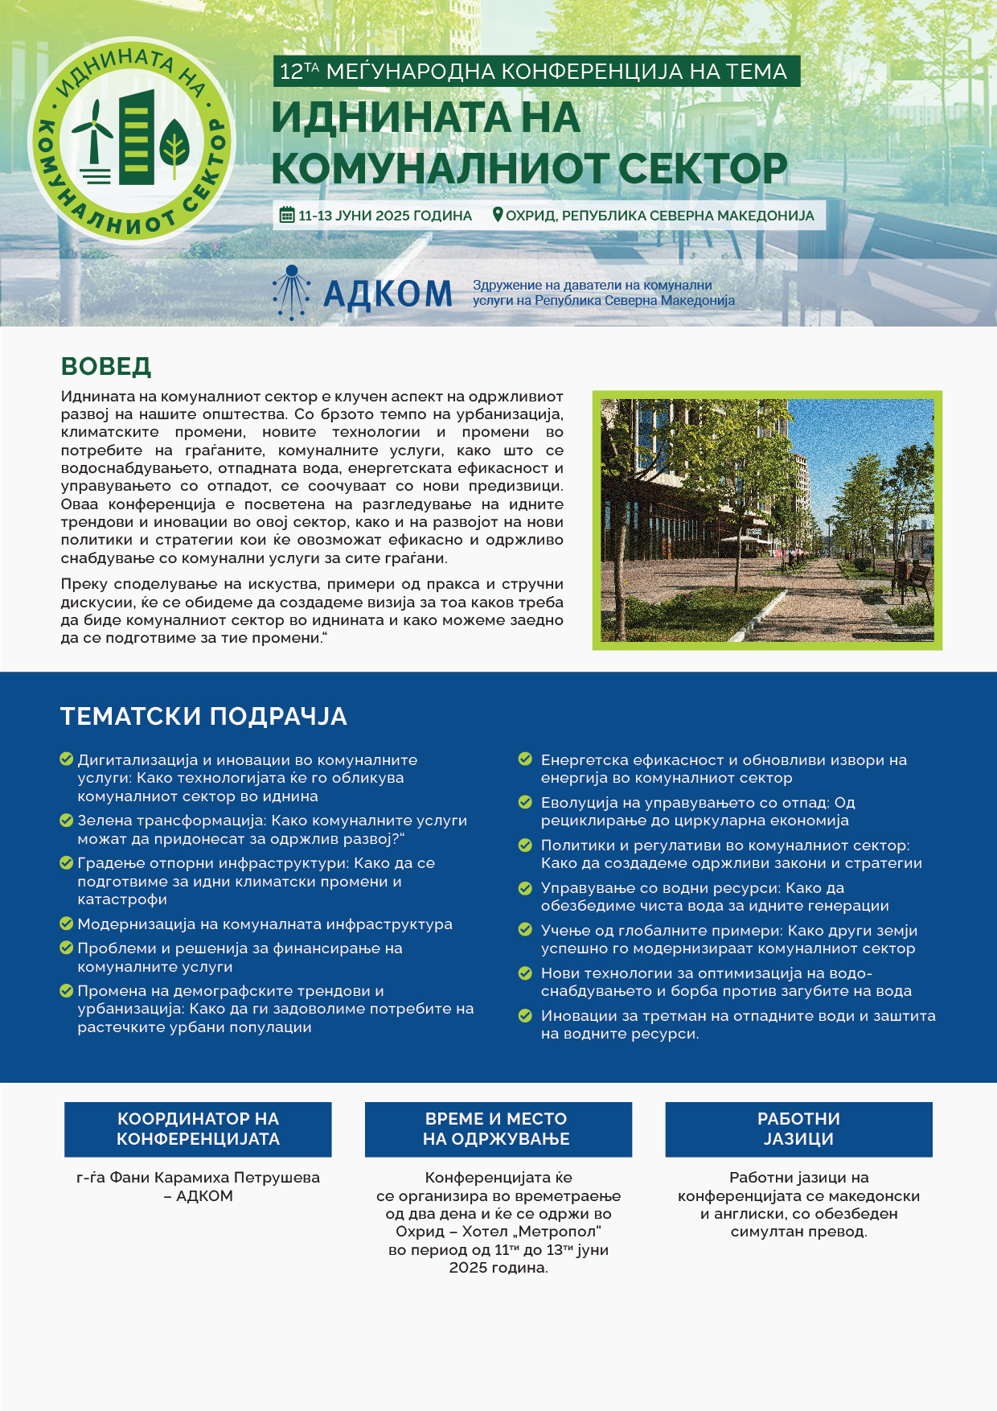

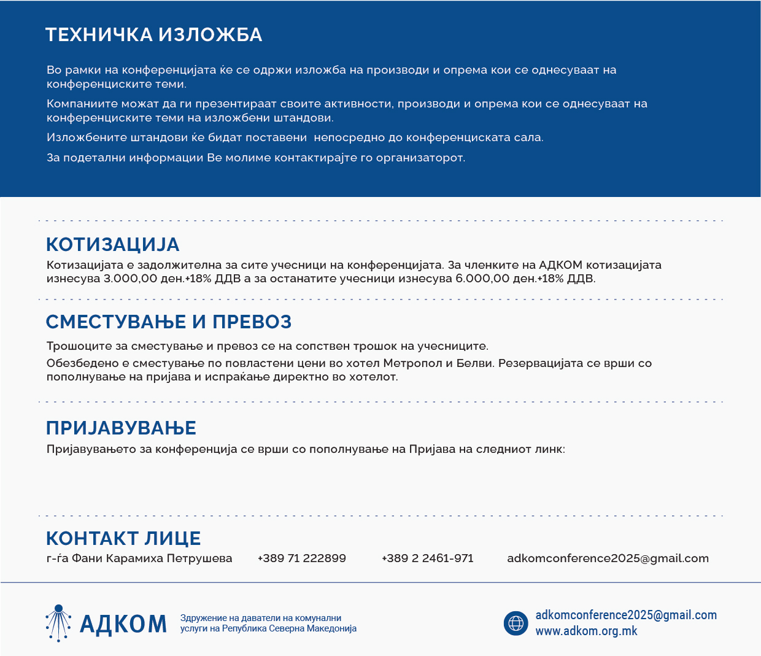

https://docs.google.com/forms/d/e/1FAIpQLSdRxrPYsawoRE44foDlE5vCy3AxkJ2WhIYIqCm0QyQjFBp5IA/viewform?usp=pp_url

